Application → Presentation → ______ → Transport → Network → ______ → Physical
Analyze the missing layers and explain how their functions are essential for reliable communication.
Introduction
The Open Systems Interconnection (OSI) Model is a standard networking model developed by the International Organization for Standardization (ISO) to explain how data is transmitted between computers over a network. It divides the communication process into seven different layers, where each layer performs a specific function. The layered architecture makes networking easier to understand, design, troubleshoot, and maintain.
Each layer communicates with the layer immediately above and below it while providing specific services. Data moves from the Application Layer to the Physical Layer at the sender's side and follows the reverse path at the receiver's side. Every layer adds or removes information to ensure that the data reaches the destination accurately and securely.
In the given concept map, two layers are missing:
- Session Layer (Layer 5)
- Data Link Layer (Layer 2)
Concept Map
Application
↓
Presentation
↓
Session
↓
Transport
↓
Network
↓
Data Link
↓
Physical
Overview of the OSI Layers
The OSI model consists of seven layers, each responsible for a different task in network communication.
Layer | Function
Application | Provides network services to user applications.
Presentation | Formats, encrypts, and compresses data.
Session | Establishes and manages communication sessions.
Transport | Provides reliable end-to-end communication.
Network | Routes packets using IP addresses.
Data Link | Transfers frames using MAC addresses.
Physical | Transmits data as electrical or optical signals.

Missing Layer 1: Session Layer (Layer 5)
The Session Layer establishes, manages, and terminates communication sessions between two devices. It acts as a communication controller, ensuring that data exchange occurs smoothly without interruption.
Whenever two computers communicate, the Session Layer creates a session before data transfer begins and closes it after communication is completed.
Functions of the Session Layer
- Establishes communication sessions between devices.
- Maintains active communication during data transfer.
- Synchronizes communication using checkpoints.
- Restores interrupted communication after failures.
- Terminates sessions after successful completion.
- Prevents data duplication and loss.
- Supports full-duplex and half-duplex communication.

Importance of the Session Layer
The Session Layer is important because long-duration communication may be interrupted due to network failures or power loss. Instead of restarting the entire transmission, checkpoints

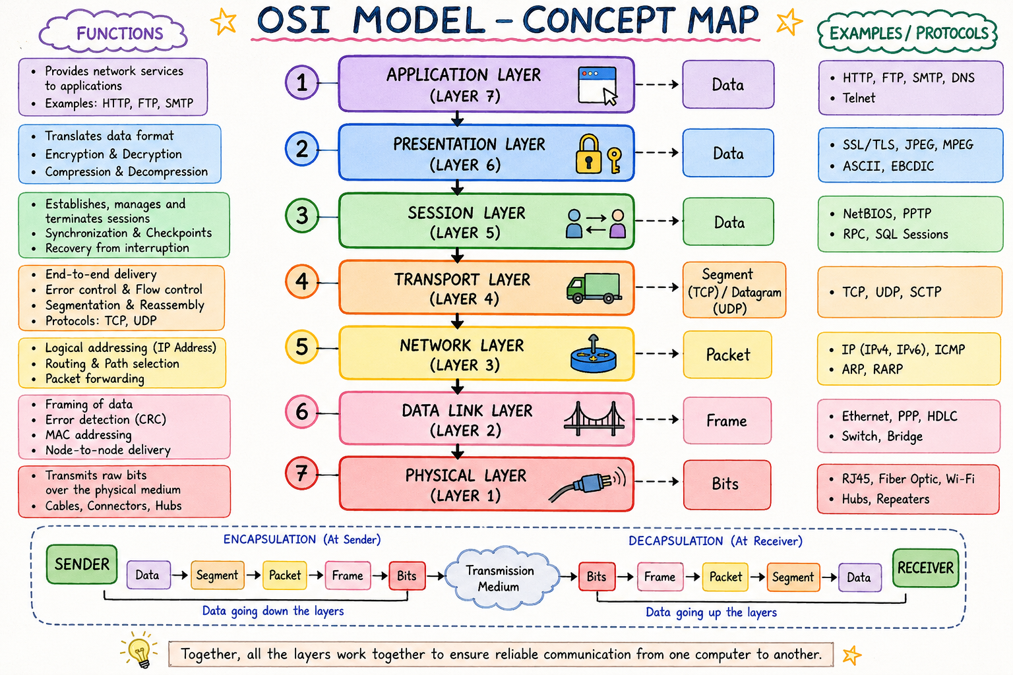

Real-Life Example
During a Google Meet or Zoom video call, the Session Layer establishes the connection, keeps the meeting active throughout the conversation, and closes the session when participants leave the meeting.

Missing Layer 2: Data Link Layer (Layer 2)
The Data Link Layer is responsible for transferring data between two directly connected devices. It converts packets received from the Network Layer into frames and performs error detection before transmission.
The Data Link Layer uses MAC (Media Access Control) addresses, which are unique physical addresses assigned to every network device.

Functions of the Data Link Layer
- Converts packets into frames.
- Adds MAC source and destination addresses.
- Detects transmission errors using CRC.
- Performs error checking before delivery.
- Controls access to the communication medium.
- Provides node-to-node communication.
- Ensures reliable delivery within the Local Area Network (LAN)
- 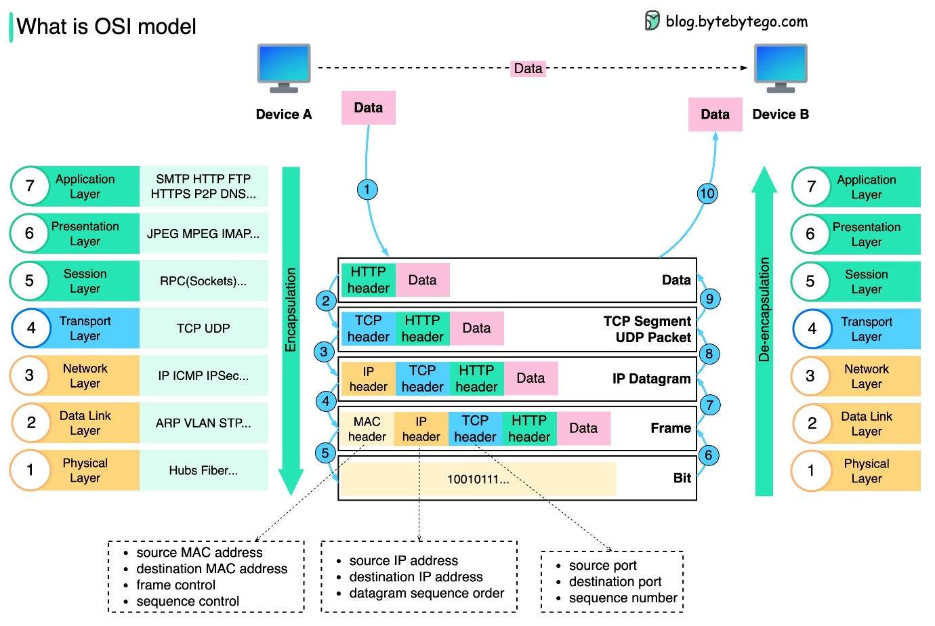

Importance of the Data Link Layer
The Data Link Layer guarantees that data is delivered correctly between neighboring devices. It detects corrupted frames and prevents damaged information from reaching higher layers.
Switches operate at the Data Link Layer by forwarding frames using MAC addresses. This improves network efficiency and reduces unnecessary traffic.
Without the Data Link Layer, devices within the same network would not be able to communicate reliably.

Real-Life Example
Suppose a student sends a file from a laptop to a printer connected to the same Wi-Fi network. The Data Link Layer uses the printer's MAC address to deliver the frame correctly through the network switch or wireless access point.

How These Layers Support Reliable Communication
Reliable communication depends on the combined operation of all OSI layers.
- The Application Layer allows users to access network services.
- The Presentation Layer formats, encrypts, and compresses data.
- The Session Layer establishes and manages communication sessions.
- The Transport Layer provides reliable delivery, sequencing, and error recovery.
- The Network Layer determines the best path using IP addresses.
- The Data Link Layer ensures error-free local delivery using MAC addresses.
- The Physical Layer transmits bits through cables, fiber optics, or wireless signals.
Together, these layers ensure that data reaches the destination safely, efficiently, and without corruption.

Advantages of the Session and Data Link Layers
Session Layer
- Prevents communication interruptions.
- Supports synchronization.
- Enables recovery from failures.
- Improves communication reliability.
- Manages multiple user sessions.
Data Link Layer
- Detects transmission errors.
- Provides reliable frame delivery.
- Uses MAC addressing for accurate communication.
- Reduces network congestion.
- Supports efficient local communication.

Applications
The Session and Data Link Layers are used in many real-world applications, including:
- Video conferencing (Zoom, Google Meet)
- Online banking
- File sharing
- Email communication
- Cloud computing
- Local Area Networks (LANs)
- Office and campus networks
- Wireless communication (Wi-Fi)

Conclusion
The missing layers in the concept map are the Session Layer and the Data Link Layer. The Session Layer is responsible for establishing, managing, synchronizing, and terminating communication sessions, while the Data Link Layer provides reliable node-to-node communication using MAC addresses and error detection mechanisms. These layers work together with the remaining OSI layers to ensure secure, efficient, and error-free communication across computer networks. Understanding the responsibilities of each layer helps network engineers design reliable systems and troubleshoot communication problems effectively.

Q 2.Construct a concept map linking data units (Segment, Packet, Frame, Bits) with their respective OSI layers and analyze how transformation of data units supports transmission.

Introduction
The Open Systems Interconnection (OSI) Model is a standard framework that explains how data is transmitted from one computer to another through a network. It consists of seven layers, and each layer performs a specific task during communication. As data travels from the sender to the receiver, it changes its format at different layers. These different formats are known as Protocol Data Units (PDUs).
The process of changing the data format while moving from the Application Layer to the Physical Layer is called Encapsulation. At the receiver side, the reverse process is called Decapsulation, where each layer removes its header and reconstructs the original data.
Concept Map
OSI MODEL

Application Layer
│
▼
Presentation Layer
│
▼
Session Layer
│
▼
Transport Layer
│
Segment
│
▼
Network Layer
│
Packet
│
▼
Data Link Layer
│
Frame
│
▼
Physical Layer
│
Bits
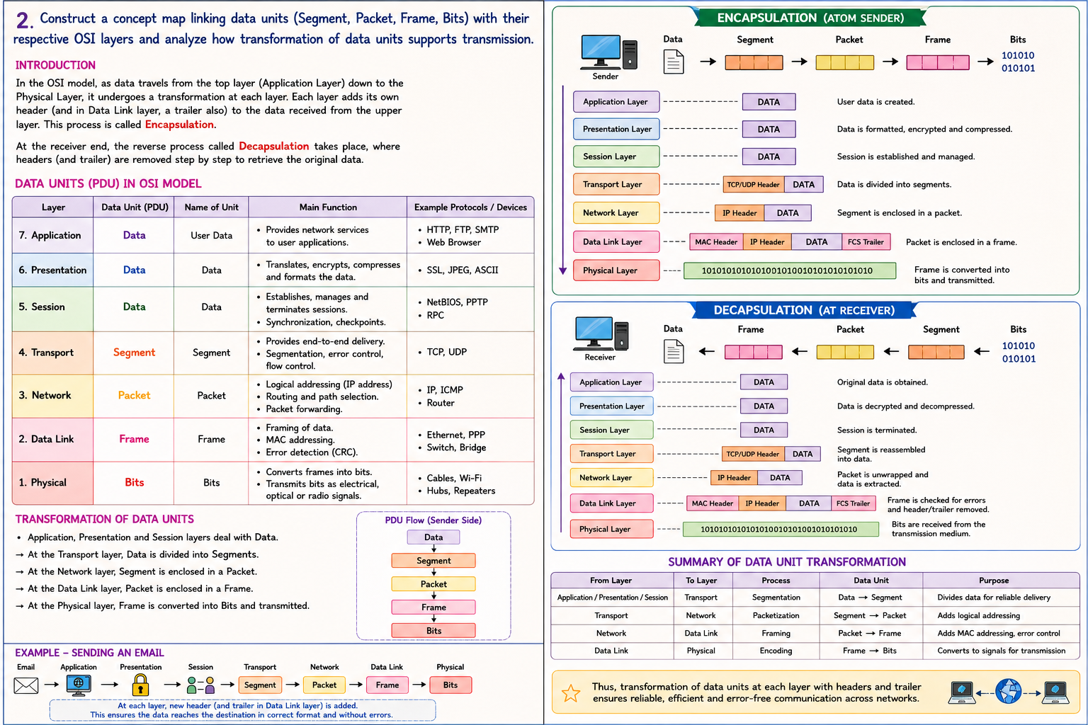
Data Units in the OSI Model
OSI Layer | Data Unit (PDU) | Main Function
Application | Data | Creates user data
Presentation | Data | Encrypts, compresses, formats
Session | Data | Manages communication sessions
Transport | Segment | Divides data into segments
Network | Packet | Adds IP Address and routing
Data Link | Frame | Adds MAC Address and error detection
Physical | Bits | Converts data into electrical signals

Explanation of Each Layer
1. Application Layer
The Application Layer is the topmost layer of the OSI model. It provides services directly to the user and allows applications like web browsers, email clients, and file transfer software to access the network.
Functions
- Provides network services
- Generates user data
- Supports HTTP, FTP, SMTP
Data Unit: Data

2. Presentation Layer
The Presentation Layer prepares the data before transmission.
Functions
- Data formatting
- Encryption
- Decryption
- Compression
Data Unit: Data

3. Session Layer
The Session Layer establishes, manages, and terminates communication sessions.
Functions
- Session establishment
- Synchronization
- Recovery after interruption
Data Unit: Data

4. Transport Layer
The Transport Layer converts the data into Segments.
A Segment is a smaller part of the original data that makes transmission easier.
Functions
- Segmentation
- Error detection
- Flow control
- Reliable communication
Protocols
- TCP
- UDP
Data Unit: Segment

5. Network Layer
The Network Layer converts Segments into Packets.
Each packet contains an IP Address, allowing routers to determine the best route to the destination.
Functions
- Logical addressing
- Routing
- Packet forwarding
Protocols
- IP
- ICMP
Data Unit: Packet

6. Data Link Layer
The Data Link Layer converts Packets into Frames.
Frames contain MAC Addresses, which are used for communication inside the local network.
Functions
- Framing
- MAC Addressing
- Error Detection
- CRC Checking
Protocols
- Ethernet
- PPP
Data Unit: Frame

7. Physical Layer
The Physical Layer converts Frames into Bits.
Bits are transmitted through cables, fiber optics, or wireless signals.
Functions
- Signal transmission
- Bit encoding
- Physical communication
Data Unit: Bits

Transformation of Data Units (Encapsulation)
During transmission, each layer adds its own information (called a Header) to the data.
Application Layer
│
Data
│
▼
Transport Layer
│
Segment
│
▼
Network Layer
│
Packet
│
▼
Data Link Layer
│
Frame
│
▼
Physical Layer
│
Bits
This process is known as Encapsulation.

Decapsulation Process
At the receiver side, the reverse operation takes place.
Bits
│
Frame
│
Packet
│
Segment
│
Data
Each layer removes its header until the original message is obtained.

Why Data Transformation is Important
The transformation of data units is necessary because every OSI layer has a different responsibility.
- Segments provide reliable communication.
- Packets allow routing between different networks.
- Frames enable local communication using MAC addresses.
- Bits allow transmission over physical media.
Without this transformation, reliable communication would not be possible.
Construct a concept map linking data units (Segment, Packet, Frame, Bits) with their respective OSI layers and analyze how transformation of data units supports transmission.

Real-Life Example
Suppose a student sends an email.
- The email is created in the Application Layer.
- The Transport Layer divides it into Segments.
- The Network Layer adds IP addresses and creates Packets.
- The Data Link Layer adds MAC addresses and converts Packets into Frames.
- The Physical Layer converts Frames into Bits and transmits them through cables or Wi-Fi.
- At the receiver side, the reverse process reconstructs the email.

Advantages of Data Unit Transformation
- Improves communication reliability.
- Supports error detection and correction.
- Enables routing across different networks.
- Ensures secure communication.
- Makes transmission faster and more efficient.
- Simplifies troubleshooting.
- Supports communication between different devices.
- 

Applications
The transformation of data units is used in:
- Internet browsing
- Online banking
- Email communication
- Video conferencing
- Cloud computing
- Online gaming
- File sharing
- Mobile communication

Conclusion
The transformation of data units from Data → Segment → Packet → Frame → Bits is an essential process in the OSI model. Each layer performs a unique task by adding headers and control information to ensure secure, reliable, and efficient communication. At the receiver side, the process of Decapsulation reconstructs the original message. This systematic approach allows data to travel accurately across local and global networks, making modern communication possible.
Q3 .Given the Concept Map:
Data Link → MAC Address → Local Delivery
Network → IP Address → Global Delivery
Explain how these relationships ensure complete data delivery across networks.

Introduction
The OSI (Open Systems Interconnection) Model divides network communication into seven layers, each performing a specific function. Among these layers, the Data Link Layer and the Network Layer are responsible for delivering data from the source to the destination. The Data Link Layer uses MAC (Media Access Control) addresses to provide communication within the same local network, while the Network Layer uses IP (Internet Protocol) addresses to deliver data across different networks.
Both addressing methods work together to ensure that information reaches the correct destination accurately, efficiently, and securely. Without MAC and IP addressing, computers would not be able to identify each other or exchange information over a network.

Concept Map
COMPLETE DATA DELIVERY

Data Link Layer
│
▼
MAC Address
│
▼
Local Delivery (LAN)

│
▼

Network Layer
│
▼
IP Address
│
▼
Global Delivery (Internet)
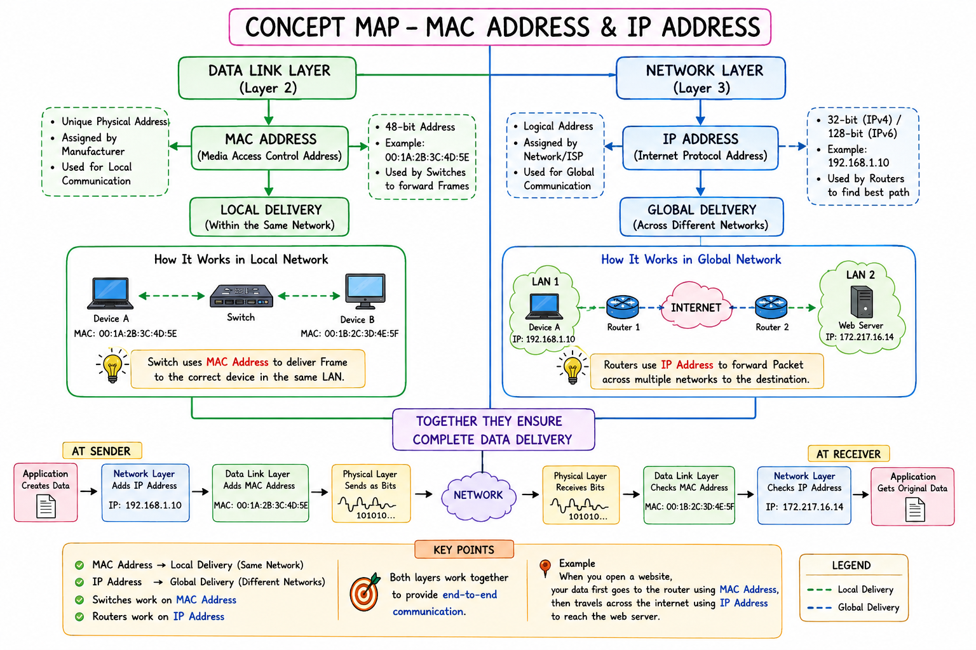

Data Link Layer → MAC Address → Local Delivery
The Data Link Layer (Layer 2) is responsible for transferring data between devices that are connected to the same Local Area Network (LAN). It converts packets received from the Network Layer into frames and delivers them to the correct device using MAC addresses.
A MAC Address is a unique physical address permanently assigned to every network interface card (NIC) by the manufacturer. Since every device has a different MAC address, it can be uniquely identified within the local network.
Functions of the Data Link Layer
- Performs framing of data.
- Uses MAC addresses for communication.
- Detects transmission errors using CRC.
- Controls access to the communication medium.
- Provides reliable node-to-node delivery.
- Ensures accurate communication within a LAN.
Importance of MAC Address
- Uniquely identifies devices on the same network.
- Helps switches forward frames to the correct destination.
- Reduces unnecessary network traffic.
- Ensures fast and reliable local communication.

Network Layer → IP Address → Global Delivery
The Network Layer (Layer 3) is responsible for communication between different networks. It converts segments into packets and adds IP addresses, which help routers determine the best path for data transmission.
An IP Address is a logical address assigned to every device connected to a network. Unlike MAC addresses, IP addresses can change depending on the network to which the device is connected.
Functions of the Network Layer
- Performs logical addressing.
- Determines the best path using routing algorithms.
- Transfers packets between different networks.
- Supports communication over the Internet.
- Avoids network congestion by selecting efficient routes.
Importance of IP Address
- Identifies devices globally.
- Enables communication across different networks.
- Helps routers forward packets.
- Supports Internet communication.
- Ensures end-to-end delivery.

Difference Between MAC Address and IP Address
Feature | MAC Address | IP Address
Layer | Data Link Layer | Network Layer
Type | Physical Address | Logical Address
Scope | Local Network | Global Network
Assigned By | Manufacturer | Network Administrator/ISP
Used By | Switch | Router
Changes | Permanent | Can Change

How Complete Data Delivery Takes Place
When a user sends data from one computer to another, the communication process follows several steps.
- The sender creates the data at the Application Layer.
- The Transport Layer divides the data into segments.
- The Network Layer adds the destination IP address, creating packets.
- The Data Link Layer adds the source and destination MAC addresses, creating frames.
- The Physical Layer converts frames into bits and transmits them through cables or wireless signals.
- Switches use MAC addresses to deliver the frame within the local network.
- Routers use IP addresses to forward packets across different networks.
- At the destination, the receiver removes the headers through decapsulation and reconstructs the original data.
This coordinated process ensures successful communication from source to destination.
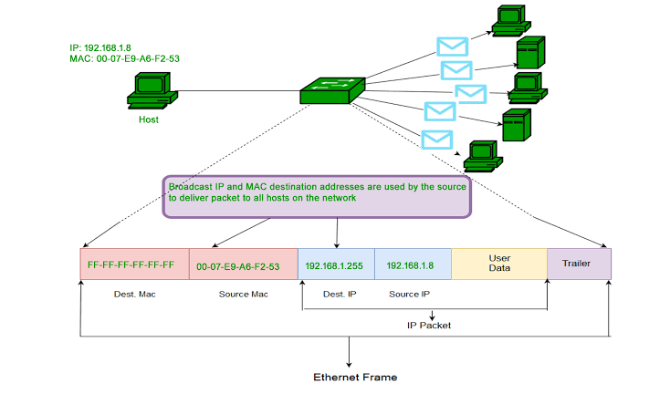

Real-Life Example
Suppose a student in Hyderabad opens the website www.google.com.
- The student's laptop first sends the data to the Wi-Fi router using the router's MAC address.
- The router then forwards the packet across the Internet using Google's IP address.
- Multiple routers guide the packet through different networks until it reaches Google's server.
- Finally, Google's local network uses the server's MAC address to deliver the data to the correct machine.
Thus, both MAC and IP addresses work together to complete the communication successfully.

Advantages
- Provides reliable communication.
- Supports communication within local and global networks.
- Enables efficient routing.
- Reduces transmission errors.
- Improves network performance.
- Allows billions of devices to communicate over the Internet.
- Makes network management easier.
- Ensures accurate data delivery.
- 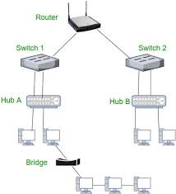

Applications
The relationship between MAC addresses and IP addresses is used in many real-world applications, including:
- Internet browsing
- Email communication
- Online banking
- Video conferencing
- Cloud computing
- File sharing
- Online gaming
- Mobile communication
- Smart home devices
- Enterprise computer networks

Conclusion
The Data Link Layer and the Network Layer play an essential role in computer networking by ensuring complete data delivery. The Data Link Layer uses MAC addresses to provide reliable communication within a local network, while the Network Layer uses IP addresses to route packets across different networks. Switches rely on MAC addresses for local delivery, whereas routers use IP addresses for global communication. Together, these addressing mechanisms ensure that data travels accurately, securely, and efficiently from the sender to the receiver. Understanding the relationship between MAC and IP addressing helps explain how modern computer networks and the Internet provide seamless communication across the world.

